User Manual
DRUM-BASED POWDER FLOWABILITY TESTER
Updated 04/28/2026

- Overview
  - Overview & Application Scope
The drum-based powder flowability tester is designed to evaluate the flow behavior of powders used in additive manufacturing and other powder-based processes. The system rotates a cylindrical drum while powder motion is observed through a transparent window.

Typical applications include:
- Comparing different powder batches
- Evaluating powder reuse conditions
- Observing powder flow behavior during drum rotation

This device is intended for laboratory-scale research and educational use.

  - Component list
ITEM NO. | SCHEMATICS | PART NUMBER | QTY.
1 | 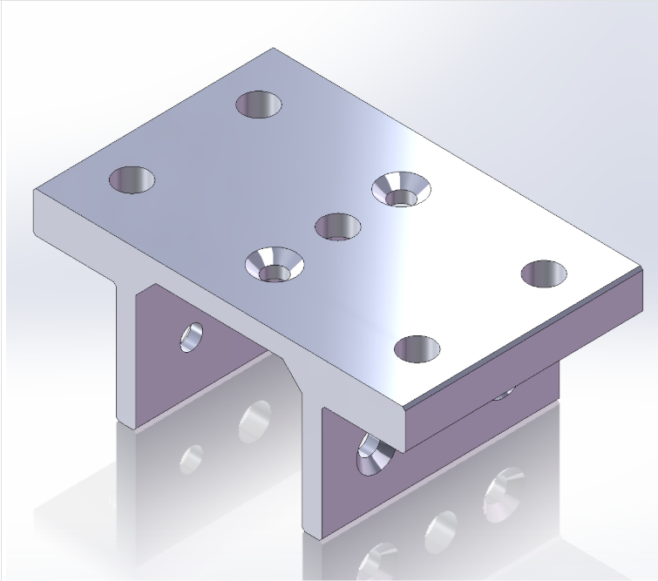 | Slider-8020-6425_642509 | 1
2 | 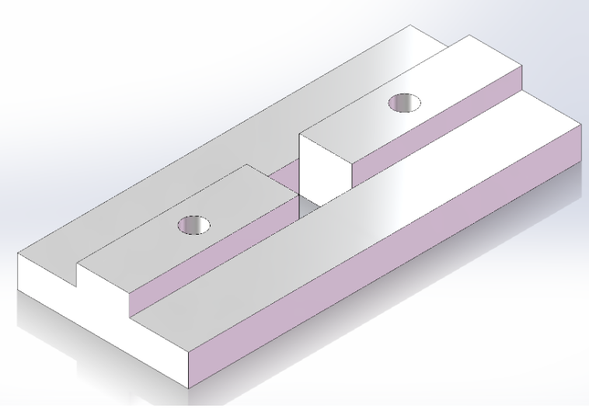 | 8020-6425_6490 | 3
3 | 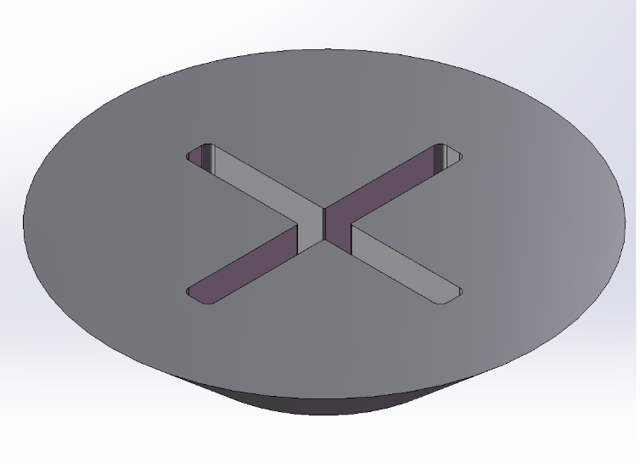 | 8020-6425_3625 | 6
4 | 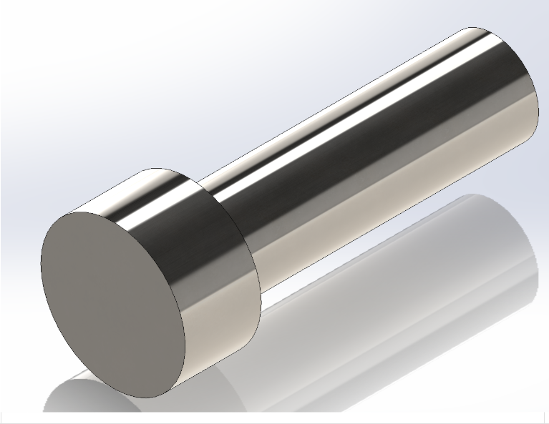 | M6-Bolt | 4
5 | 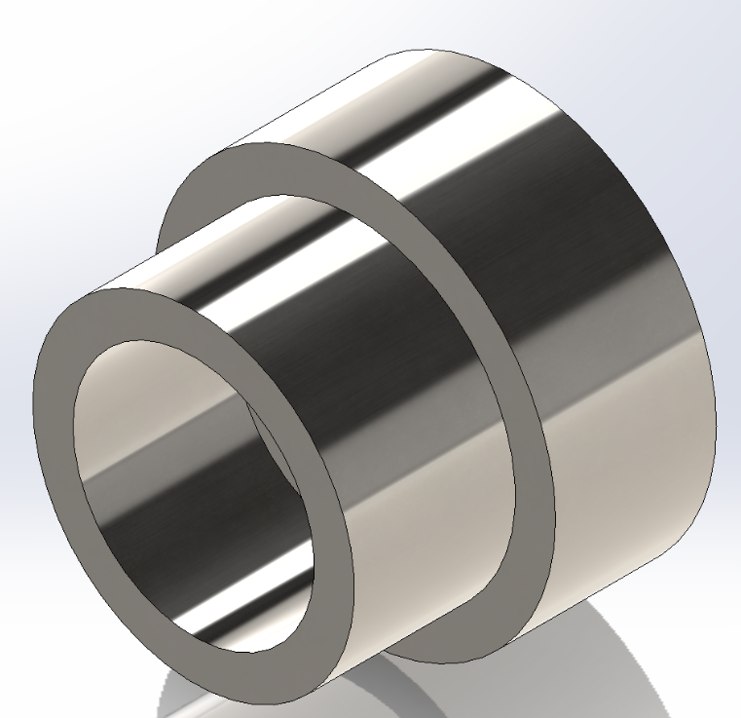 | M6-nut | 4
6 | 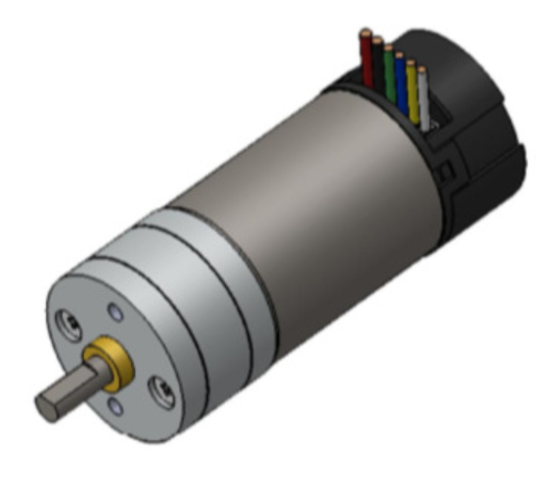 | Motor | 1
7 | 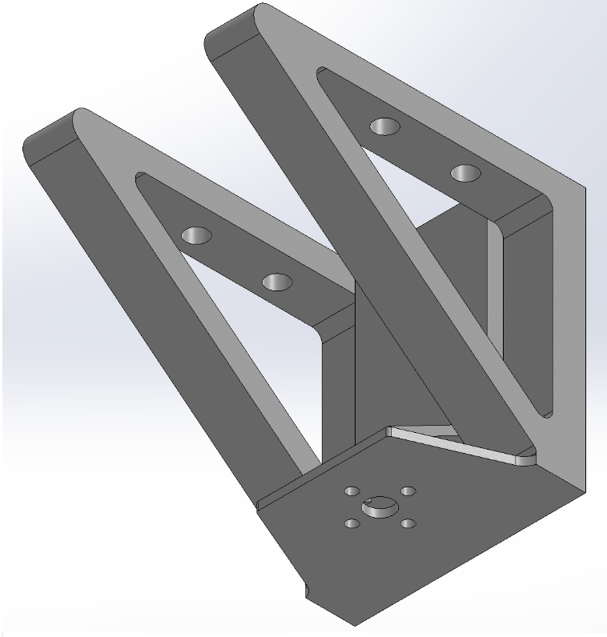 | Motor Platform | 1
8 | 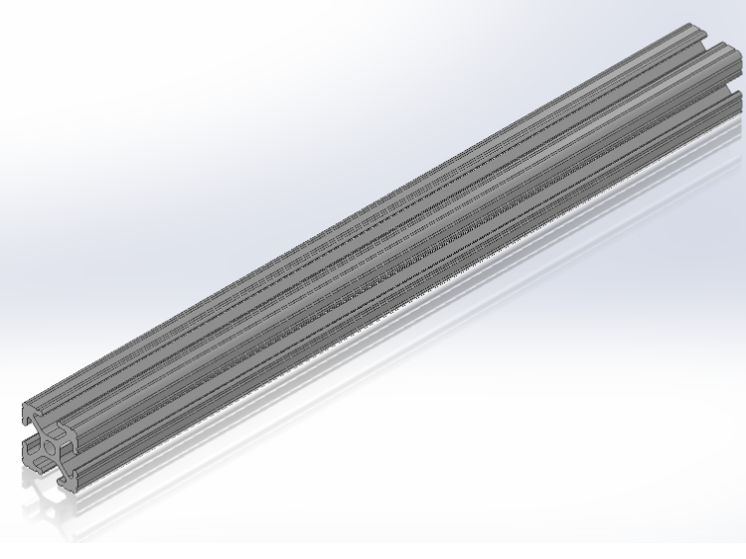 | T-slot-1010 X 12 | 1
9 | 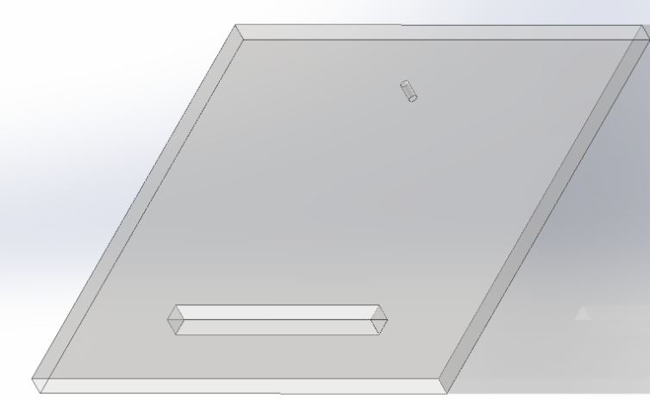 | Base | 1
10 | 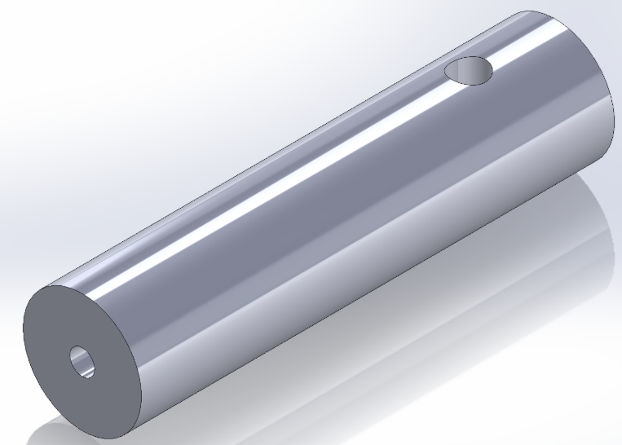 | Shaft | 2
11 | 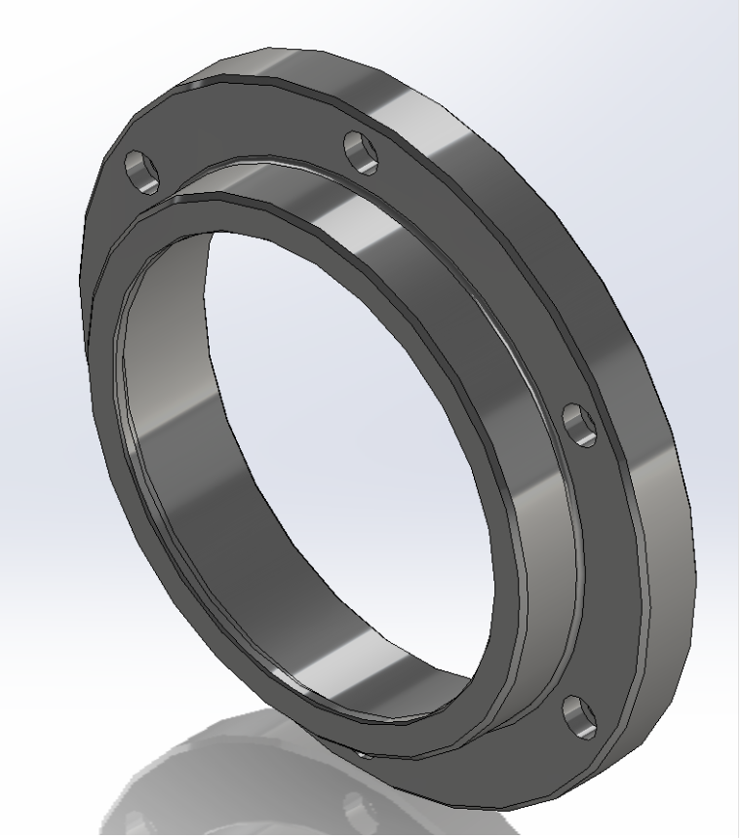 | Top | 1
12 | 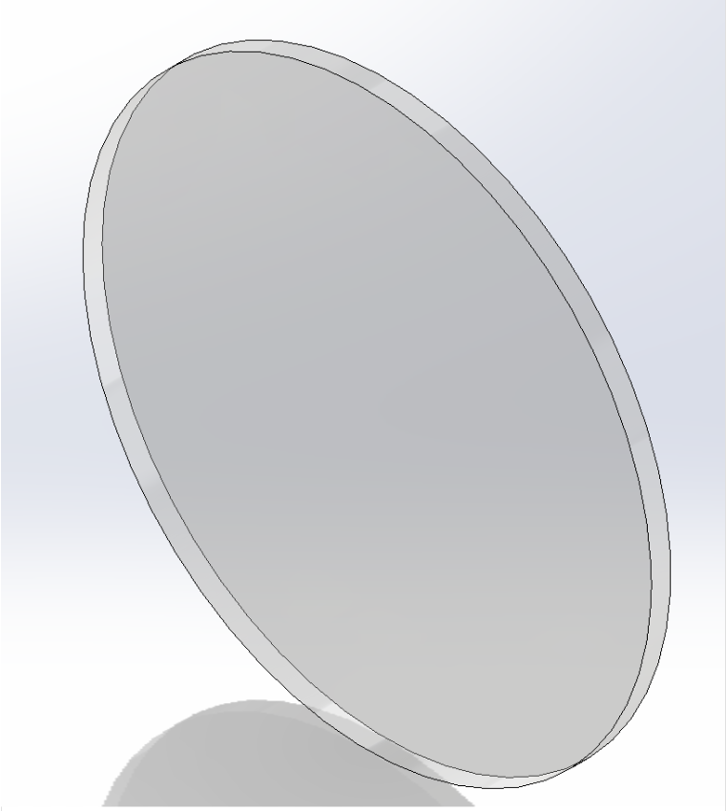 | Window | 1
13 | 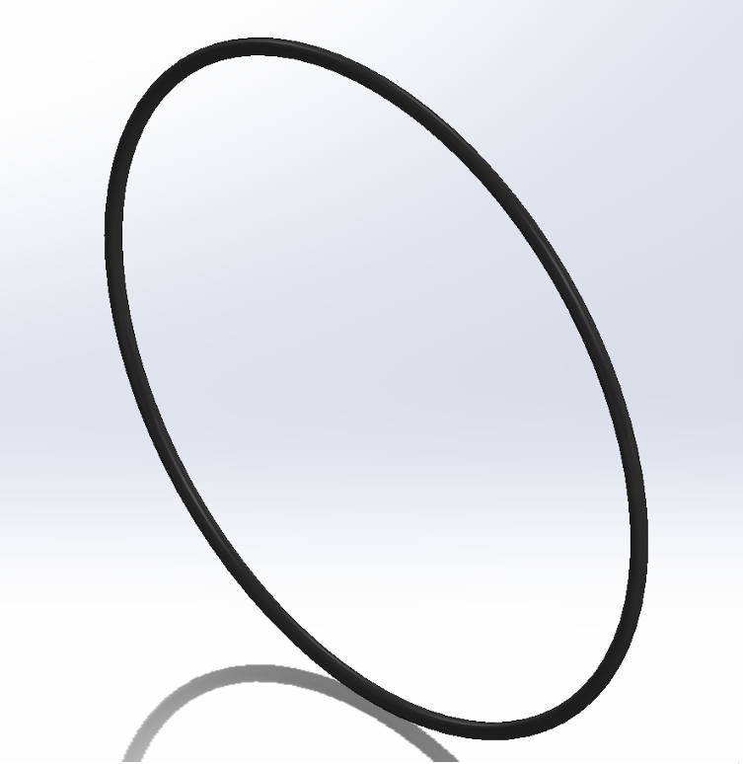 | O-ring | 1
14 | 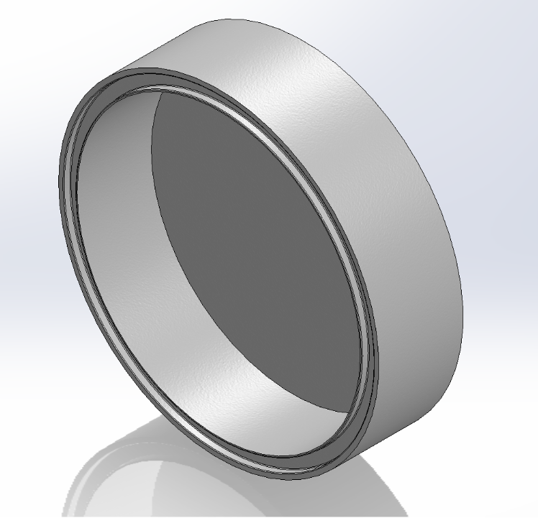 | Bottom | 1
15 | 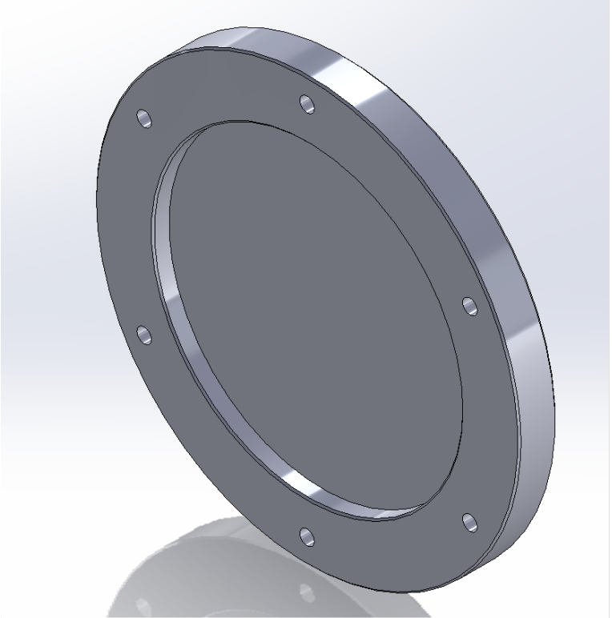 | Backplate | 1
16 | 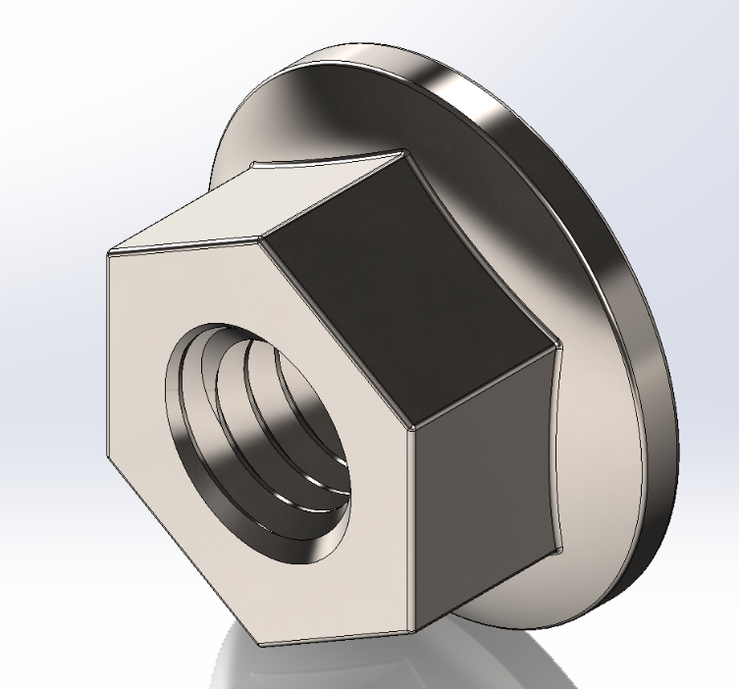 | M4-Nuts | 6
17 | 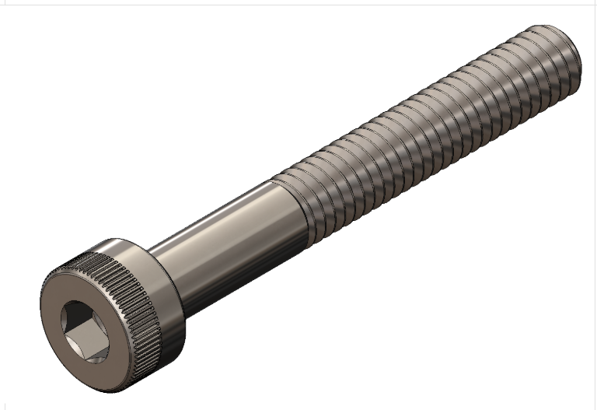 | M4-Bolts | 6
18 | 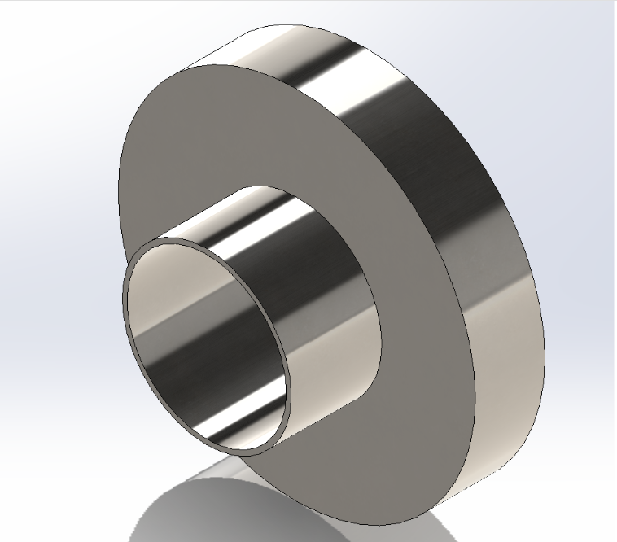 | M8-Nut | 2
19 | 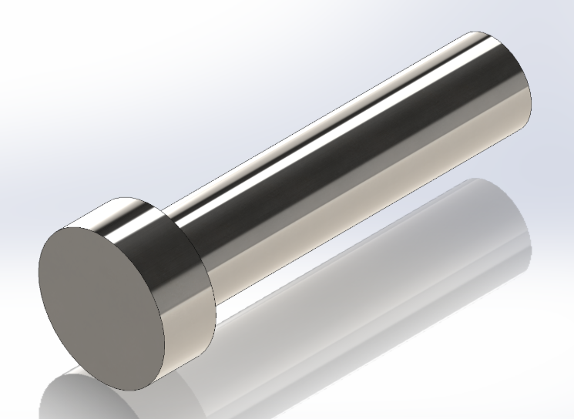 | M8-Bolt-35mm | 2
20 | 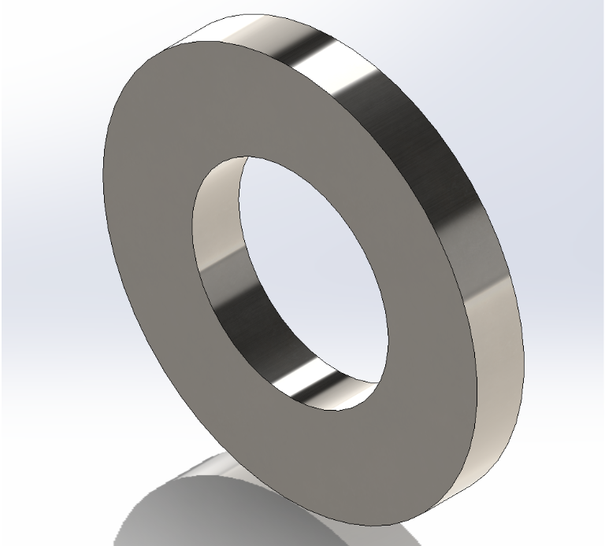 | M8-Washer | 6
21 | 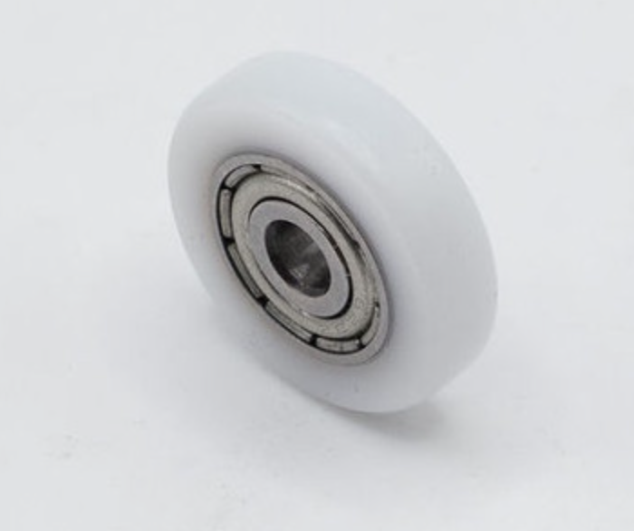 | Roller | 2
22 | 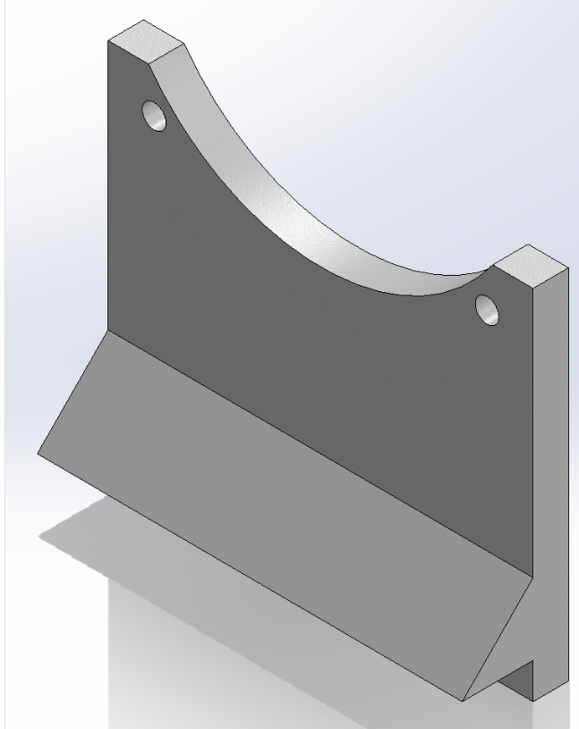 | Bracket | 1
23 | 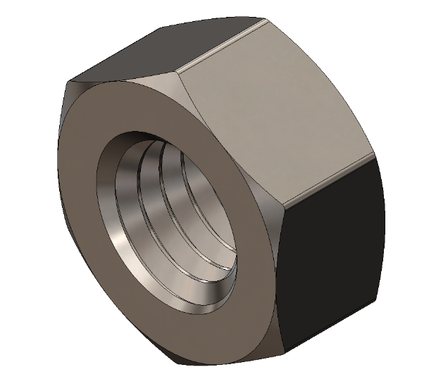 | M5-Nut | 1
24 | 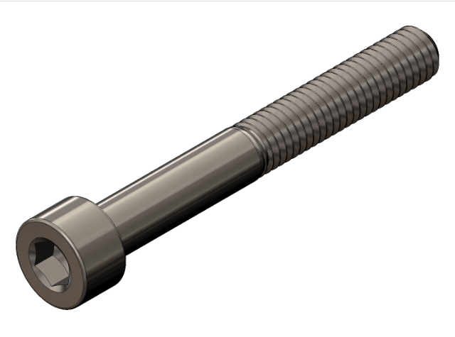 | M5-Bolt | 1
25 | 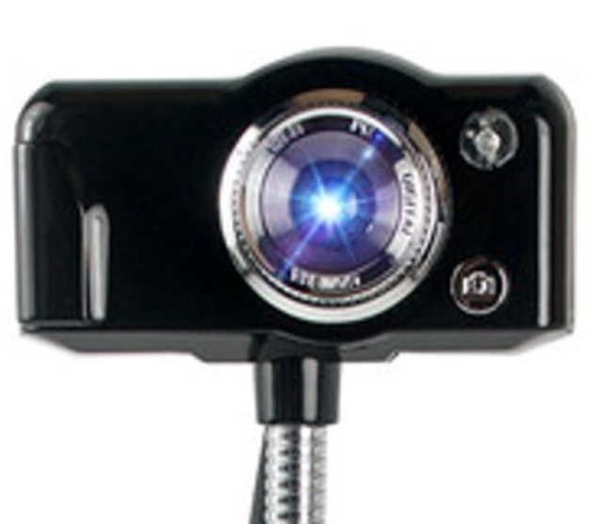 | Camera | 1
26 | 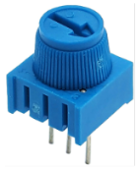 | Potentiometer | 1
27 | 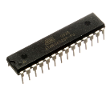 | ATmega328P Microcontroller | 1
28 | 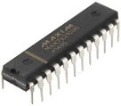 | MAX7221Display Driver | 1
29 | 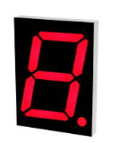 | 7-Segment Display | 3
30 | 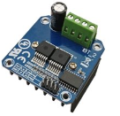 | H-Bridge | 1
31 | 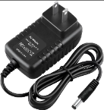 | 9V AC adapter  power supply | 2
32 | 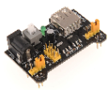 | Breadboard power supply | 1
33 | 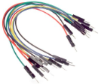 | Jumper Wires | As Required

  - Equipment and material preparation
Materials:
- Powder sample
- Cleaning wipes or lint-free cloth
- Acetone
- Soft brush
Equipment:
- Drum-based powder flowability tester system
- Power supply (standard laboratory wall outlet)
- Laptop with MATLAB (Toolboxes needed)
  - MATLAB Image Processing Toolbox
  - MATLAB Supporting Package for USB Webcams
- Spatula
- Beaker
- Safety requirements
  - Lab environment
- Stable and level working surface (minimum 15 × 20in area)
- Clean workspace in an enclosed room with adequate ventilation
- Adequate lighting for observing powder movement
- Sufficient surrounding space for safe operation
- Access to a standard laboratory electrical outlet
- Low-vibration operating environment
  - PPE
The following PPE should be worn when handling powders and operating the system:
- Safety glasses
- Protective gloves
- Laboratory coat

Additional protection may be required depending on the powder type:
- Dust mask or respirator (for fine powders)
- Protective sleeves or additional clothing if required by laboratory safety guidelines
- Operating instruction 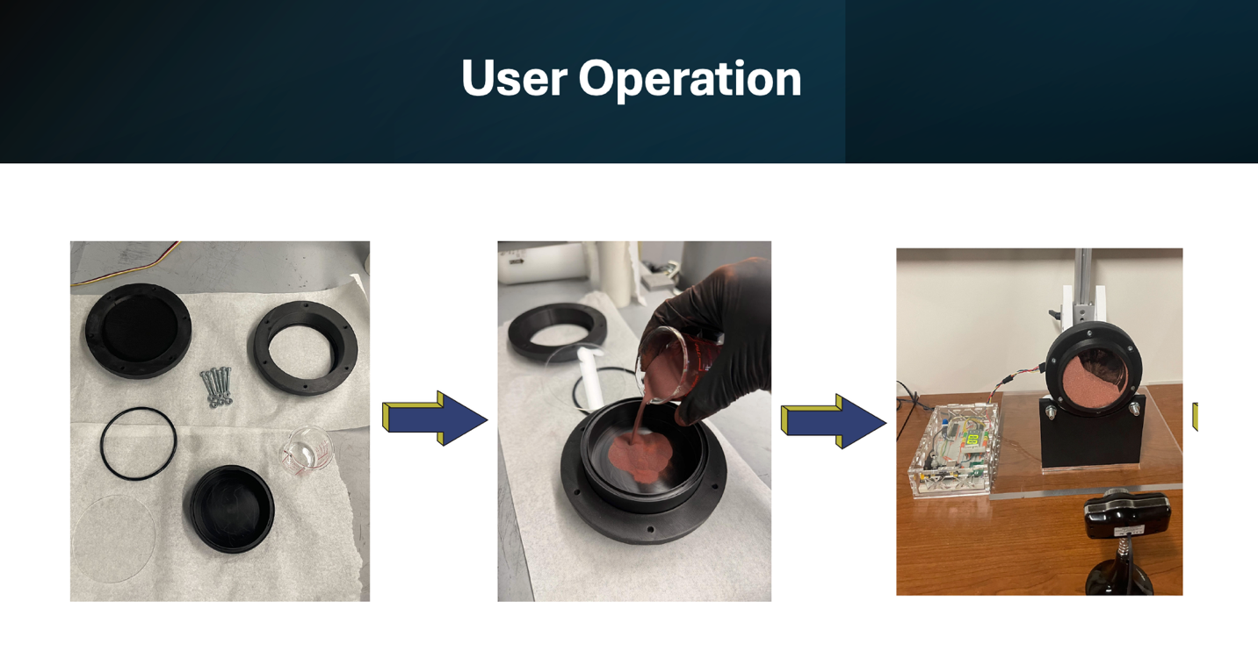
  - System assembly
Frame and Base Assembly
- Place the acrylic baseplate on a flat, stable work surface. Ensure the surface is level and free of deformation.
- Secure the T-slot aluminum profiles onto the baseplate using bolts.
Note: Tighten loosely at first, then align and fully tighten to ensure parallelism and perpendicularity.
Roller Bearing System Assembly
- Insert the bearing bracket into the designed slot on the acrylic baseplate
- Assemble the roller on each side in the following order:
M8 bolt head – washer – roller- spacer – washer – bearing bracket – washer – nut
Note: Ensure the assembly and installation of rollers on each side are identical and ensure the roller can rotate freely before the next step.
Motor Platform Sub-Assembly
- Attach the motor bracket to the slider using four M6 Bolts in the following order:
M6 bolt head – washer -slider – washer -nut
Note: Secure the motor bracket firmly to the slider before proceeding to the next step.
Motor Installation
- Place the Motor on the motor bracket and fasten the motor to the front wall using two M3 bolts
Note: Ensure the motor output shaft is level.
Shaft and Coupling Assembly
- Install the shaft coupler onto the motor output shaft
- Tighten the set screws to secure the coupler
Note: The motor output shaft is D-shaped, so ensure the flat surface is aligned.
- Connect the other side of the coupler to the drum interface and secure it
Final Integration and Adjustment
- Insert the fully assembled motor-slider system into the T-slot
- Adjust the slider height so that the drum rests evenly on both rollers.
Note: Ensure even contact on both sides and no eccentric rotation
- Fully tighten the slider after alignment is achieved.
- Wiring the encoder on the motor to the control box
Function Check
- Manually rotate the drum and do the following checklist:
Wobbling/roller synchronization/resistance on the drum
- Run the motor at low speed and do the following checklist:
Stable rotation/Obvious vibration
  - load/unload powder
- Place the drum on a clean and stable surface
- Measure the required volume of powder according to the test plan.
- Slowly pour the powder into the drum, avoiding powder spillage or contamination of the sealing area.
- After loading, gently check that the powder remains mainly at the bottom of the drum. Manual compaction of the powder is not required.
  - test set-up
Drum Assembly
- Place the O-ring into the sealing groove at the front of the drum. Make sure it is flat and not twisted.
- Align the transparent observation acrylic window and front cover with the front side of the drum. If a window with a film is being used to reduce static, ensure the treated side is that which contacts the drum.
- Insert the mounting screws through the corresponding holes. There will be a gap between the top hat and the backplate—this is intentional.
- Tighten the screws gradually in a diagonal sequence to apply uniform pressure to the front cover. An allen wrench or pair of pliers may be beneficial for ease of tightening.
Note: Do not overtighten the screws, as this may damage the transparent window or deform the O-ring.
Drum-Shaft Assembly
- Place the loaded drum onto the device frame and connect it to the shaft coupler. Slide the bolt through both the drum backplate and the shaft coupler, tightening them together with the respective nut.
- Ensure that the outer surface of the drum is properly and evenly supported by the two support rollers.
- Check that the drum does not interfere with the frame, camera, or other components during rotation.
Note: If obvious eccentric motion, shaking, or vibration is observed, stop the operation and recheck the drum alignment.
Image DAQ Set-up
- Position the camera directly in front of the drum.
Note: The camera lens should be aligned with the center of the drum.
- Adjust the camera distance so that the entire transparent window and powder region are visible in the frame.
Note: The camera positioning will be evaluated when running the script.
- Ensure stable lighting conditions and avoid strong reflections or shadows on the observation window.
  - testing procedure
- Plug in the power supply of the control box and the motor.
- Turn on the control box using the button on the top.
- Adjust the target rotational speed using the knob until the targeted rpm is reached.
Note: Observe whether the drum rotates smoothly and whether the displayed speed is stable.
Note: During the test, avoid touching the drum, frame, motor platform, or camera.
-----------------------------------------------------------------------------------------------------------------
Aside: Using the MatLab Scripts
- MatLab Image Processing Toolbox and MatLab Support Package for USB Webcams is required.
- Operate everything from User_Main.m, but the additional functions and singular class file must be accessible in the working directory.
- In User_Main.m
  - Read the documentation at the top, adjust the filepath to the desired output folder accordingly, ensure the parameters set within the first block align with your set up.
  - Run the first block of code.
  - Proceed to the section labeled “Initialization” and run.
    - Follow the prompts to first adjust the location and position of the camera and then confirm the camera settings.
  - Proceed to the section labeled “Collect all data” and run.
    - Follow the prompts to enter the rpm the drum is rotating at and then allow the script to run for the full time needed.
    - Repeat this using the prompts that appear for however many rpms are of interest.
  - Proceed to the section labeled “Testing” and run.
  - Once the previous step is finished, proceed to the section labeled “Plotting” and run.
-----------------------------------------------------------------------------------------------------------------
  - test shutdown
- Set the rpm to 0 and wait until the drum completely stops rotating.
- Turn off the control box.
- Cut off the power supply of both the control box and the motor.
- After the drum is fully stationary, unlock the braker, pull up the motor bracket to be away from the rollers.
- Remove the drum and shaft coupler.
- Open the drum’s front cover, pour out the powder sample, and handle the powder in accordance with laboratory safety requirements.
- Clean the inside of the drum, the transparent observation window, and the sealing area before the next test.

  - System disassembly
Safety Preparation Electrical Disconnection
- Turn off the system using the switch on the top surface of the box, and disconnect the power supply from the control box and the motor
Note: Ensure the motor has completely stopped rotating before proceeding to the next step
Drum and Shaft Removal
- Loosen the set screws on the shaft coupler
- Carefully take off the drum from the coupler
- Remove the shaft coupler from the motor output shaft
Motor Removal
- Remove the M3 bolts used to secure the motor to the front wall of the motor bracket
- Lift the motor away from the bracket
Optional Slider Removal
- If required, loosen the slider locking bolts and remove the motor-slider assembly from the T-slot.
Retained Components
- The following components can be retained if no further maintenance is required:
T-slot/base plate/roller bearing system
- Maintenance manual
  - Preventive regular maintenance
Drum Cleaning and Maintenance
- Clean the drum after each test to remove residual powder.
- Use compressed air for dry cleaning.
- Avoid water unless material compatibility is confirmed.
- Replace the window glass if scratches and imperfections are spotted

Roller and Bearing Maintenance
- Ensure rollers rotate freely without resistance
- Check for abnormal noise or vibration
- Remove dust particles between the drum and the roller
- Check whether the contact conditions between the drum and each roller are identical
Motor Check
- Inspect the shaft coupling and check looseness
- Verify the alignment between the motor output shaft and the drum
- Ensure the motor output shaft is horizontal without tilt

Fasteners and Frame Integrity
- Check all M6/M8 bolts for loosening
- Inspect T-slot connections
- Re-tighten if necessary

Electrical System Inspection
- Verify wiring connections between all electronic components
- Check encoder/Hall sensor signals
- Confirm proper grounding
- Ensure a stable power supply

  - Troubleshooting, emergency SOP, etc.
- Motor Not Rotating
Possible Causes: Power supply failure, loose wiring, H-bridge malfunction, low rotational speed

Solutions
- Check the voltage input
- Reconnect wiring
- Replace the driver, if necessary,
- Adjust the rotational speed slowly

- Unstable Rotation
Possible Causes: Shaft misalignment, uneven rollers contact, and load-distributing condition on each side; loose fasteners of bolts connecting the motor, frame, or rollers; drum imbalance due to powder distribution or manufacturing asymmetry

Solution:
- Realign motor shaft and drum (ensure coaxially)
- Adjust roller positions for symmetric contact, or adjust the height of the motor
- Tighten all structural bolts (M6/M8)
- Redo the load of powder or rebalance the drum
- Large RPM Fluctuation
Possible Causes: Voltage drops or insufficient current supply, friction changes due to roller/bearing condition

Solutions
- Ensure a stable power supply (adequate current capacity) and check and secure all wiring connections
- Reduce friction (clean/lubricate bearings)

